**GURU NANAK DEV ENGINEERING COLLEGE LUDHIANA**

**Department Of Information Technology Assignment-1**

**Subject: Advance Web Technogy**

**5th SEMESTER, 2018 Batch**

**July- Dec 2020**

**Submitted To :- Submitted By :-**

**Name:- kavish thakur**

**Prof. Ranjodh kaur Class:-D3,IT/A2**

**(Department of IT) U.R.N:-1805520**

**C.R.N:-1821104**

**Assignment – 1**

**Basic Commands Of Git**

1. **Create a directory in your machine and make it as a repository.**

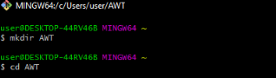

**2.Create a file and add some content into it.**

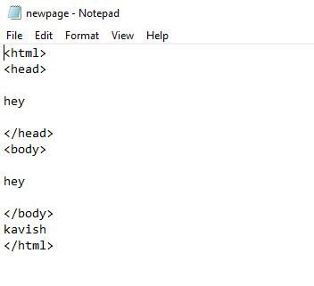

**3.Add the file to the staging area of the Git repository.**

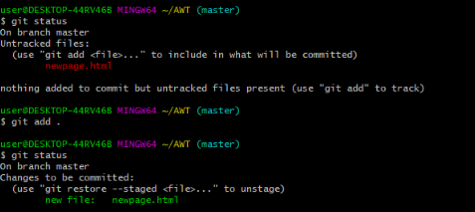

**4. Commit the file to your repository**.

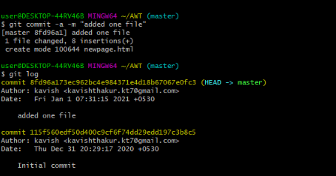

**5.See the commit details using git log command**

